

ANTI-BULLYING (INCL. CYBER) POLICY

This policy includes the Early Years Foundation Stage (EYFS)
Policy reviewed: June 2023, 3rd June 2025/10th August 2025/11th August 2026
Policy to be reviewed: 10th August 2027

This policy should be read in conjunction with the Safeguarding Policy.

Aims

St Wystan’s School aims to encourage good behaviour and respect for others and in particular prevent all forms of bullying amongst its pupils so that they can develop their full potential. The School community is made up of pupils and adults from a variety of cultural, religious and ethnic backgrounds, and relies on mutual tolerance, courtesy and co-operation in order that learning can take place in an orderly atmosphere.

Bullying, harassment, victimisation and discrimination will not be tolerated. The School aims to treat staff, pupils and their parents fairly and with consideration and expects everyone to do likewise. Where necessary, sanctions (which are described in the Behaviour Management & Discipline policy) will be applied for behaviour that constitutes bullying or harassment of any kind.

This policy is informed by, and will be reviewed annually in line with, the Department for Education’s Keeping Children Safe in Education (KCSIE) statutory guidance (latest update: September 2026). All staff will be trained to understand their safeguarding responsibilities in preventing and responding to bullying, including child-on-child abuse, and will follow the procedures set out in the School’s Safeguarding Policy.

Context of the policy

This policy should be read in conjunction with:
- Complaints Procedure
- Curriculum Policy
- Behaviour Policy
- Safeguarding and Child Protection Policy
- Supervision Policy
- Missing Child Policy
- Online Safety Policy
- PSHE Schemes of Work

Definition of bullying

Although there is no legal definition for bullying, St Wystan’s School recognises bullying as a behaviour by an individual or group, usually repeated over time, which intentionally hurts another individual or group, either physically or emotionally. Bullying often involves an imbalance of power between pupils. This imbalance may be physical, psychological or social and may also arise through online influence or access to information. A single incident may not meet the definition of bullying; however, this does not mean that it will be treated less seriously. A one-off incident may constitute harassment, discrimination, violence, child-on-child abuse or another safeguarding concern and will be responded to accordingly.. We recognise that staff assessing incidents of alleged or actual bullying will investigate all cases and will use the above definition to support them in identifying the incident. Bullying can be physical, verbal or psychological. It can happen face-to-face or through cyberspace. Bullying is often motivated by prejudice. It may not involve direct participation but may include manipulating a third party to tease or torment someone.

Examples of unacceptable bullying behaviour include:

(Bullying may be direct or indirect)
- Verbal abuse, including name-calling, teasing or making offensive remarks;
- Spreading rumours;
- Online or cyberbullying: the use of digital technology, including messaging services (group as well as individual), social media, online games and gaming platforms, sharing or manipulation photographs or videos, to deliberately hurt, intimidate, embarrass or exclude another person. (see Online Safety Policy);
- Physical assault, including pushing, pinching and hitting;
- False friendships;
- Emotional torment by excluding from social groups;
- Coercion;
- Actions or comments which discriminate against someone because of their age, race including colour, nationality or ethnic origin, religion, sex, or sexual orientation, disability, a person’s status as adopted or as a carer or Special Educational Needs;
- Prejudice-based and discriminatory bullying;
- Sexist or sexualised bullying and harassment;
- Bullying related to SEND, disability or perceived difference

Note: this is not an exhaustive list.

Anti-bullying procedures Guidance and Procedures for Staff:

- Verbal abuse should never be viewed as ‘banter’ or as a part of growing up or as a means of ‘toughening up’ young people;
- Where bullying behaviour may constitute child-on-child abuse or otherwise raises a safeguarding concern, it must be reported immediately to the DSL or Deputy DSL and managed in accordance with the Safeguarding and Child Protection Policy;
- Parents will be informed and next steps discussed. The strength of the home and School relationship can be pivotal in bringing about a resolution;
- Where online bullying is reported, pupils and parents should be encouraged, where safe and appropriate, to preserve evidence such as messages, screenshots, usernames, dates and times rather than deleting it.
- The seriousness of bullying is acknowledged by the sanctions used to respond to it. It can ultimately lead to exclusion if it is persistent and severe. Please see the St Wystan’s Behaviour Policy for more detail;
- Support for both the pupil who has experienced bullying and the pupil who has displayed bullying behaviour will be provided in terms of emotional and physical care. Work may be done in group or individual sessions;
- The Form Teacher and Deputy Head will monitor behaviour and liaise to help manage desired outcomes;
- Parental involvement will continue until a satisfactorily stable situation is achieved. This decision will rest with the Form teacher and the Deputy Head;
- Detailed records will be kept on SharePoint to evaluate the effectiveness of the approach adopted or to enable patterns to be identified by the Deputy Head.

Preventing and Identifying Bullying
The School will:
  - Aim to prevent bullying and work to safeguard and promote the welfare of all pupils;
  - Have clear policies communicated to all parents, pupils and staff and create an environment of good behaviour and rapport;
- Discuss bullying and prevention with pupils during assemblies, form time and house meetings;
  - Work with teaching staff and outside agencies to identify all forms of prejudice;
  - Ensure both staff and pupils are aware of the seriousness of bullying and the consequences of ignoring it. Staff understand that bullying can have a significant and sometimes long-lasting impact on a child's emotional wellbeing, mental health, attendance and ability to learn.Implement disciplinary sanctions, which reflect the seriousness of an incident and which convey an effect, in line with the ‘Behaviour Policy’;
  - Provide opportunities to develop pupils’ social and emotional skills, including their resilience. This would include targeted input during PSHCE sessions and through assemblies, news items, charitable drives, use of case studies or projects in English and Drama, etc. The importance of highlighting prejudice-based language is key;
  - Consider all opportunities for addressing bullying including through the curriculum, through displays, through peer support and through the modelling of behaviour;
  - Train all staff to identify bullying, understand the principles of and follow School policy and procedures on bullying. Staff will understand their legal responsibilities; the action required to resolve and refer problems, and be aware of sources of support available;
  - This approach is centred on safeguarding the child and ensuring his/her welfare through the investigation and after the sanction has been served by the pupil who has displayed bullying behaviour. The sensitive and considerate management of the relationship between the bullied and the pupil who has displayed bullying behaviour will be of paramount importance;
  - The reliance of the children on us to get it right must encourage us all to keep communication with the children frequent and open:
    - assemblies, including external speakers, explain the School policy on bullying, and encourage reflection;
    - pupil surveys facilitate an understanding of the level and type of bullying which may have been experienced by pupils;
    - the PSHE programme is structured to give pupils an awareness of their social and moral responsibilities. It enforces the message about the importance of taking care of each other;
    - other lessons, particularly RE, English and drama highlight the issue of bullying and reinforce the message that bullying is unacceptable;
    - all reported incidents of bullying are recorded and investigated. Records are regularly monitored and evaluated in order to identify patterns at SLT meetings;
    - all staff are trained to be alert to possible signs of bullying;

    - the Deputy Head will give support and guidance to other staff on handling and reporting incidents, and on the follow-up work with both the pupil who has experienced bullying and the pupil who has displayed bullying behaviour;
    - prefect system of support and mentoring;
    - in consultation with the Headteacher, staff will refer individuals about whom they have social, emotional or behavioural concerns to the Senior Mental Health Lead. The SMHL will meet with parents to discuss next steps for support;
    - support will be given to any member of the community, especially at a time of family break-up, sickness or bereavement;
    - staff are on duty at lunch times and after School and are alert to areas where bullying might occur. Inappropriate language or behaviour is always challenged;
    - incidents that take place outside School hours, on School visits and trips and that occur off-site involving our pupils are investigated
    - involvement of parents ensuring pupils are clear about how they can prevent bullying;
    - feedback from parents/guardians on effectiveness of our preventative measures is welcomed.
The School's Relationships and Health Education and PSHE provision supports the prevention of bullying by teaching pupils, in an age-appropriate way, about respectful relationships, kindness, consent and boundaries, prejudice and discrimination, online safety and harmful online influences.
Signs of bullying
All members of the School community must be alert to the signs of bullying.

- Unwillingness to return to School;
- Displays of excessive anxiety, becoming withdrawn or unusually quiet;
- Failure to produce work, or producing unusually bad work, or work that appears to have been copied, interfered with or spoilt by others;
- Books, bags and other belongings suddenly go missing, or are damaged;
- Change to established habits (e.g. giving up music lessons, change to accent or vocabulary);
- Diminished levels of self-confidence leading to psychological damage;
- Frequent symptoms such as stomach pains, headaches;
- Frequently waiting to speak to the teacher at the end of lessons;
- Unexplained cuts and bruises;
- Frequent absence, erratic attendance, late arrival to class;
- Choosing the company of adults;
- Displaying repressed body language and poor eye contact;
- Difficulty in sleeping, experiences nightmares;
- Talking of self-harm or running away.

Involvement of pupils:
The School will:

  - Celebrate our pupils’ differences;
  - Canvas pupils’ views on the extent and nature of bullying and cyber-bullying;
  - Ensure pupils know how to express worries and anxieties about bullying both in and out of School; this includes ensuring they know who to tell. It is more important to report an incident, than to worry about who exactly to tell;
  - Ensure all pupils are aware of the range of sanctions which may be applied against those engaging in bullying (see the School’s Behaviour Policy). More so that pupils work within an environment of good behaviour and respect, with helpful examples set by staff, older pupils and celebration of success;
  - Ensure pupils are clear about the part they can play to prevent bullying including when they find themselves as bystanders, outsiders or defenders;
  - Publicise the details of help lines and charities who support children;
- Offer support to pupils who have been bullied;
- Work with pupils who have been bullying to address the problems they have.

Bullying and the Protected Characteristics

As a School, we are committed to looking at individual cases of bullying through the lens of the protected characteristics and other vulnerabilities, including SEND, being adopted or being a young carer.When managing cases of bullying, we log any possible protected characteristics and other vulnerabilities that the the pupil who has experienced bullying may possess and review these cases to ensure that we are active in preventing further bullying targeted at particular protected characteristics and other vulnerabilities.

Our approach aligns with the Department for Education’s “Behaviour in Schools” guidance (2024), which requires all schools to take active steps to prevent prejudice-based and discriminatory bullying, including incidents related to any protected characteristic or other vulnerability,under the Equality Act 2010. This includes ensuring that pupils with SEND or other vulnerabilities receive support and that preventative strategies address both in-person and online contexts.

Responding to and Preventing Bullying at St Wystan’s School

St Wystan’s staff will follow the Anti-Bullying Alliance’s ten steps to responding to and preventing bullying.

- Listen
Staff will listen to all pupils and will always have time to listen to their concerns and worries. We aim to ensure that all pupils feel confident talking to a trusted adult, and we provide a variety of ways of reporting concerns, such as the ‘worry box’.
- Celebrate Difference
St Wystan’s School is extremely proud of the differences that exist in our pupil, parent and staff bodies. We are constantly looking for opportunities to celebrate the differences between us and we use ‘Celebrate Difference’ as a School motto. We take time to recognise the individual and group achievements of our School population and our holistic approach to the child means that we constantly celebrate individual achievement and success.
- Include all
All pupils, including those with SEND or disability, those with a protected characteristic, staff and parents, are included, valued and participate fully in all aspects of School life. Inclusion is: being welcomed, being actively involved, being a part and never apart, people expecting you, going where you want to go and getting help when you need it.
- Report bullying
All members of the St Wystan’s school community are clear on how to report bullying and clear, detailed and timely records are kept of all cases of bullying. All cases will be discussed with SWS’s Governing Body.
- Believe
All pupils, including disabled children and those with SEN, and their parents and carers are acknowledged, believed and taken seriously when reporting incidents of bullying.
- Take action
We respond quickly to all incidents of bullying. Pupils, including disabled pupils and those with SEN, participate fully in decisions made about them and help to formulate appropriate action to respond to incidents of bullying. We keep pupils informed of actions taken.
- Understand
Time is given in lesson time, assemblies, INSET and conversations with staff, parents and pupils to ensure that St Wystan’s School community understands what constitutes bullying and what does not.
- Challenge the language we use
All forms of discriminatory language are challenged and taken seriously.
- Respect
All School staff act as role models to our pupils and are vital in demonstrating appropriate inclusive behaviour.
- Our anti-bullying policy
The principles set out in this policy underpin the ethos of our school and are actively promoted.

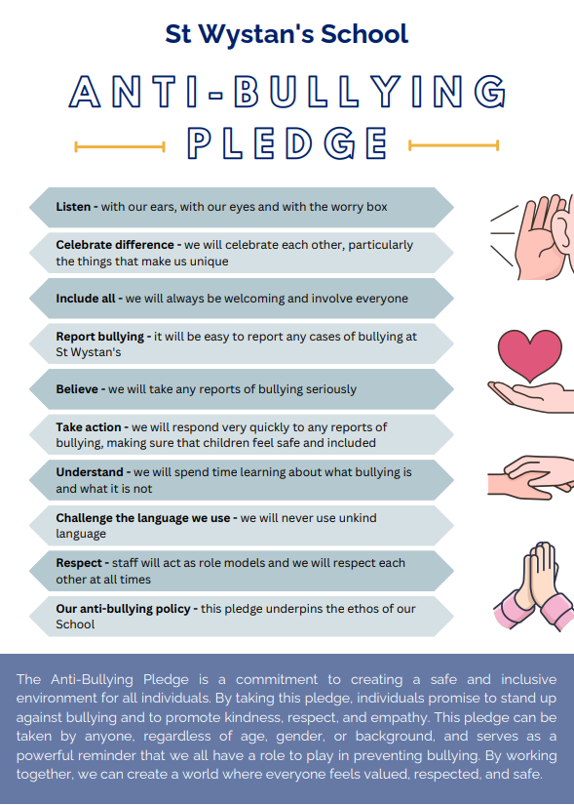

REVIEW
This policy will be reviewed on a one-year rolling programme.

Updated by | Mrs Catherine Ralph
Date Updated | 2nd June 2023, 3rd June 2025, 11th August 2026
Date of Next Review | 10th August 2027
Governing Body Approval | Yes/No | Signed/Dated
Website/App | Yes/No | ISI | Yes/No
Staff Handbook | Yes/No | Parent Handbook | Yes/No

